Organic Food Store Architecture and High-level Design

# 1. Architecture

## Diagram:

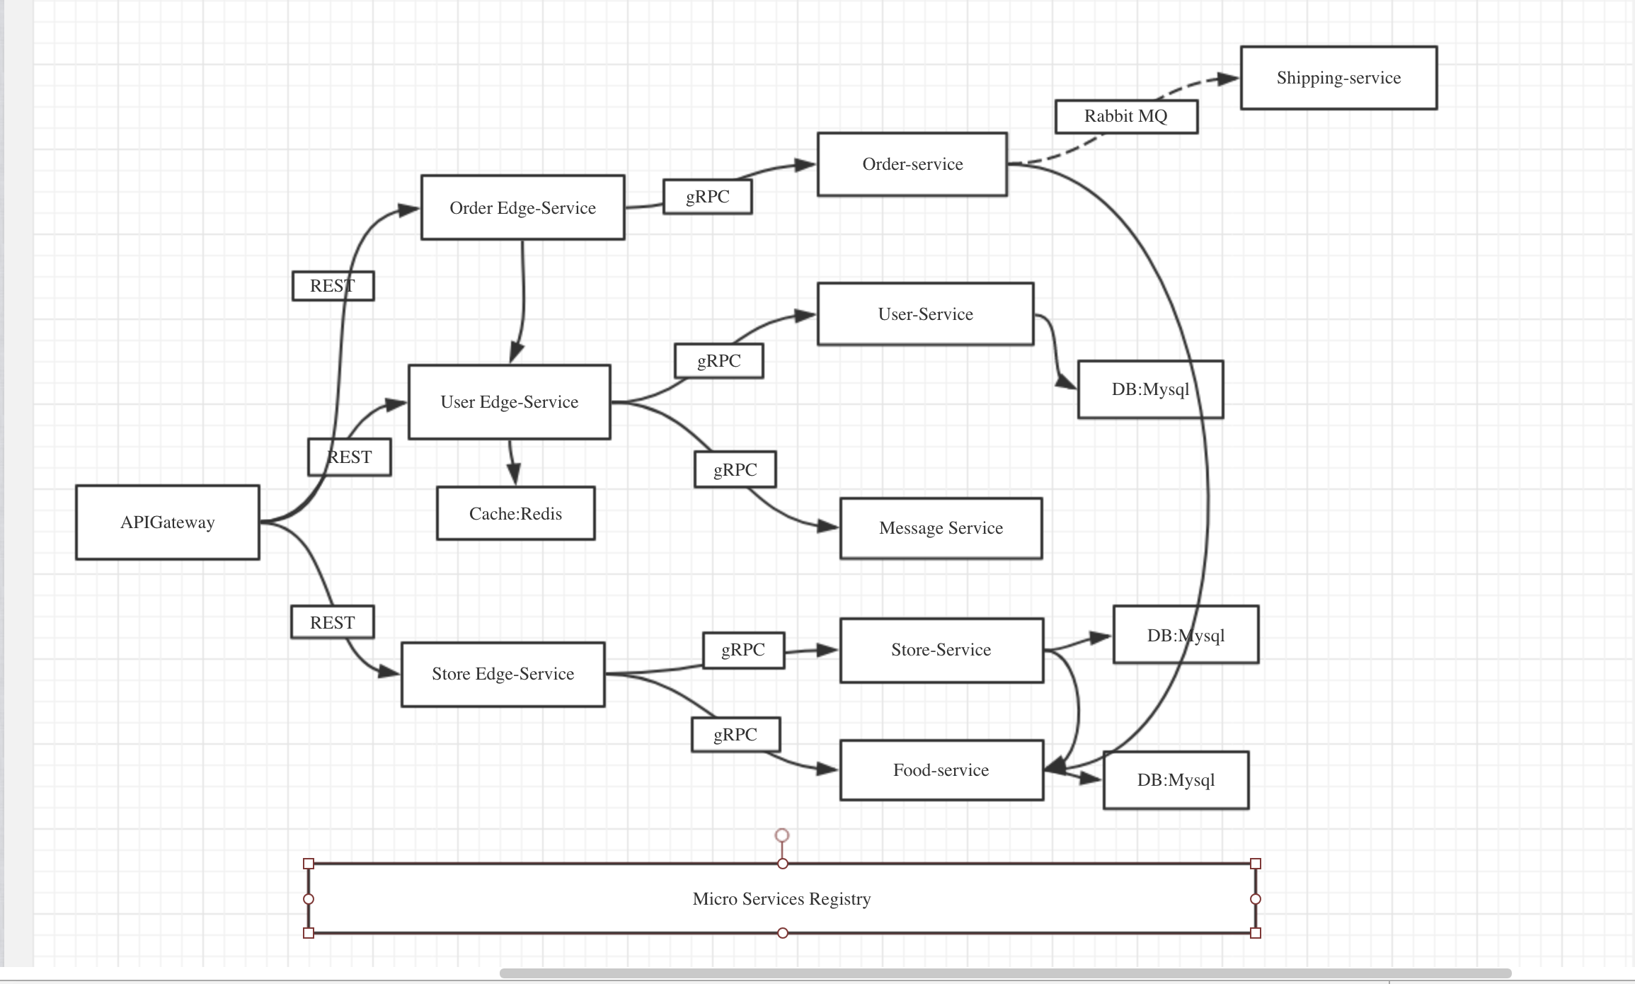

# 

# 

# 2. Component design:

* Store location recommendation system
  + Analysis of the population density of the county to find most dense district in order to recommend store location. 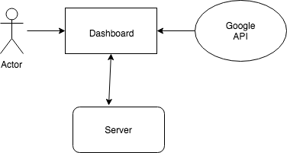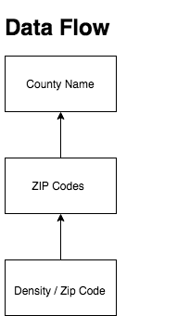
* Online shopping website
  + Dynamically display the available items
  + Virtual shopping cart
  + Implement weight limit in the shopping cart
  + Online payment system
* Delivery tracking system
  + Use google map API to navigate delivery drones
  + Use google map API to display the moving drone on the map

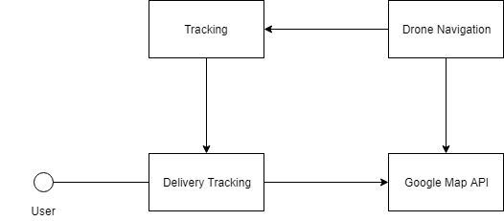

* Inventory management System
  + Allows store employee to manage the store inventory, such as restock.
  + A direct interface between employee and the database.

# 3.Tools:

* Linux
* Nginx,
* Docker
* Kubernetes
* Jenkins -CI/CD
* MySQL - AWS RDS
* Redis

# 4. Frameworks:

* Python
* Flask (Web testing framework)
* Unittest (Python testing framework)

# 5.Library:

* Google API